Ethan Elders

00099962

February 24, 2024

Assignment 3

1. Find the errors.

// This program uses an if/else if statement to assign a

// letter grade (A, B, C, D, or F) to a numeric test score.

#include <iostream>

using namespace std;

int main()

{

int testScore;

cout << "Enter your test score and I will tell you\n";

cout << "the letter grade you earned: ";

cin >> testScore;

if (testScore < 60)

cout << "Your grade is F.\n";

else if (testScore < 70)

cout << "Your grade is D.\n";

else if (testScore < 80)

cout << "Your grade is C.\n";

else if (testScore < 90)

cout << "Your grade is B.\n";

else

cout << "That is not a valid score.\n";

else if (testScore <= 100)

cout << "Your grade is A.\n";

return 0;

}

1. Find the errors

// This program uses a switch-case statement to assign a

// letter grade (A, B, C, D, or F) to a numeric test score.

#include <iostream>

using namespace std;

int main()

{

double testScore;

cout << "Enter your test score and I will tell you\n";

cout << "the letter grade you earned: ";

cin >> testScore;

switch (testScore)

{

case (testScore < 60.0):

cout << "Your grade is F.\n";

break;

case (testScore < 70.0):

cout << "Your grade is D.\n";

break;

case (testScore < 80.0):

cout << "Your grade is C.\n";

break;

case (testScore < 90.0):

cout << "Your grade is B.\n";

break;

case (testScore <= 100.0):

cout << "Your grade is A.\n";

break;

default:

cout << "That score isn't valid\n";

return 0;

}

1. Understanding how time works
   1. 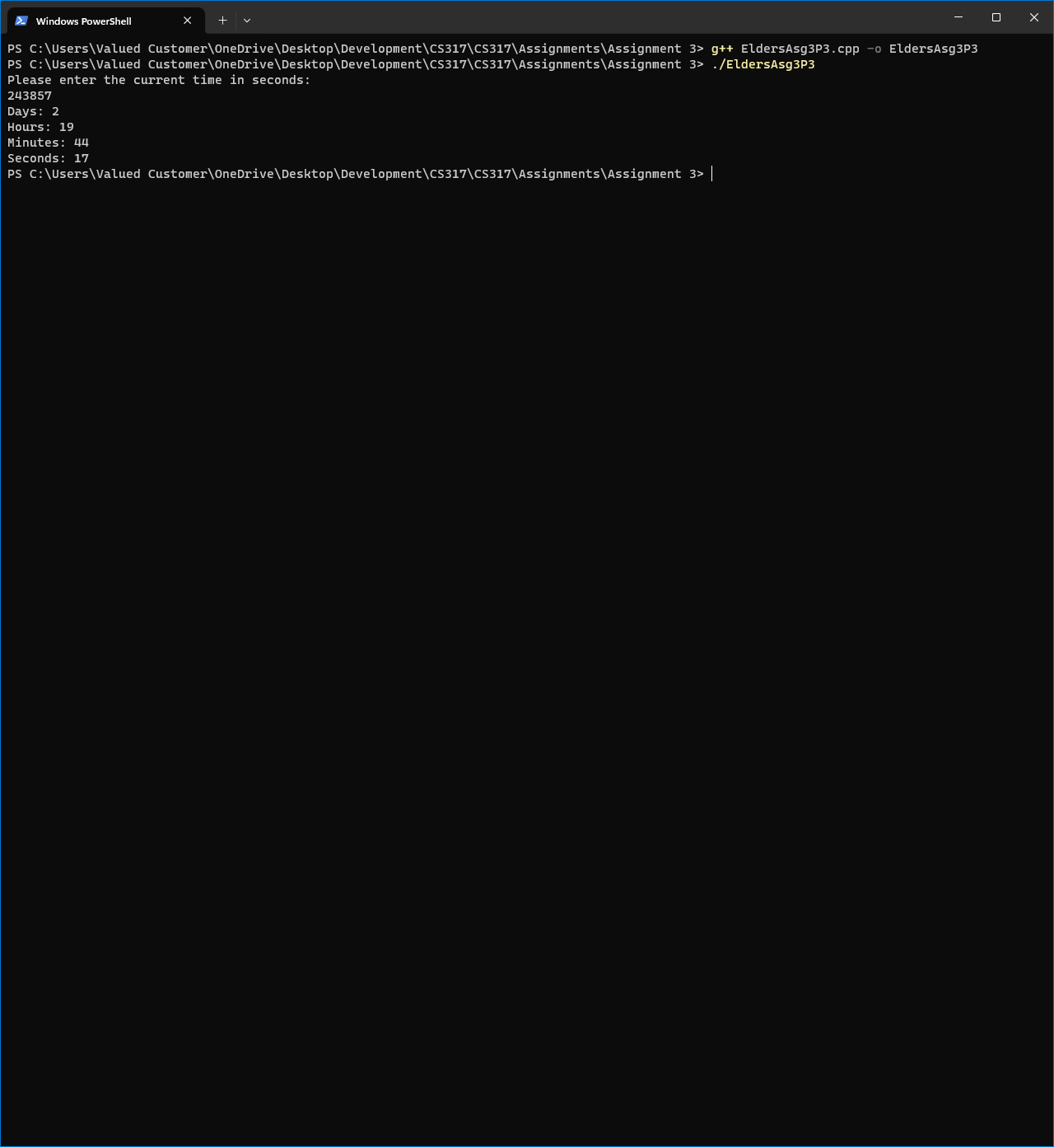
   2. 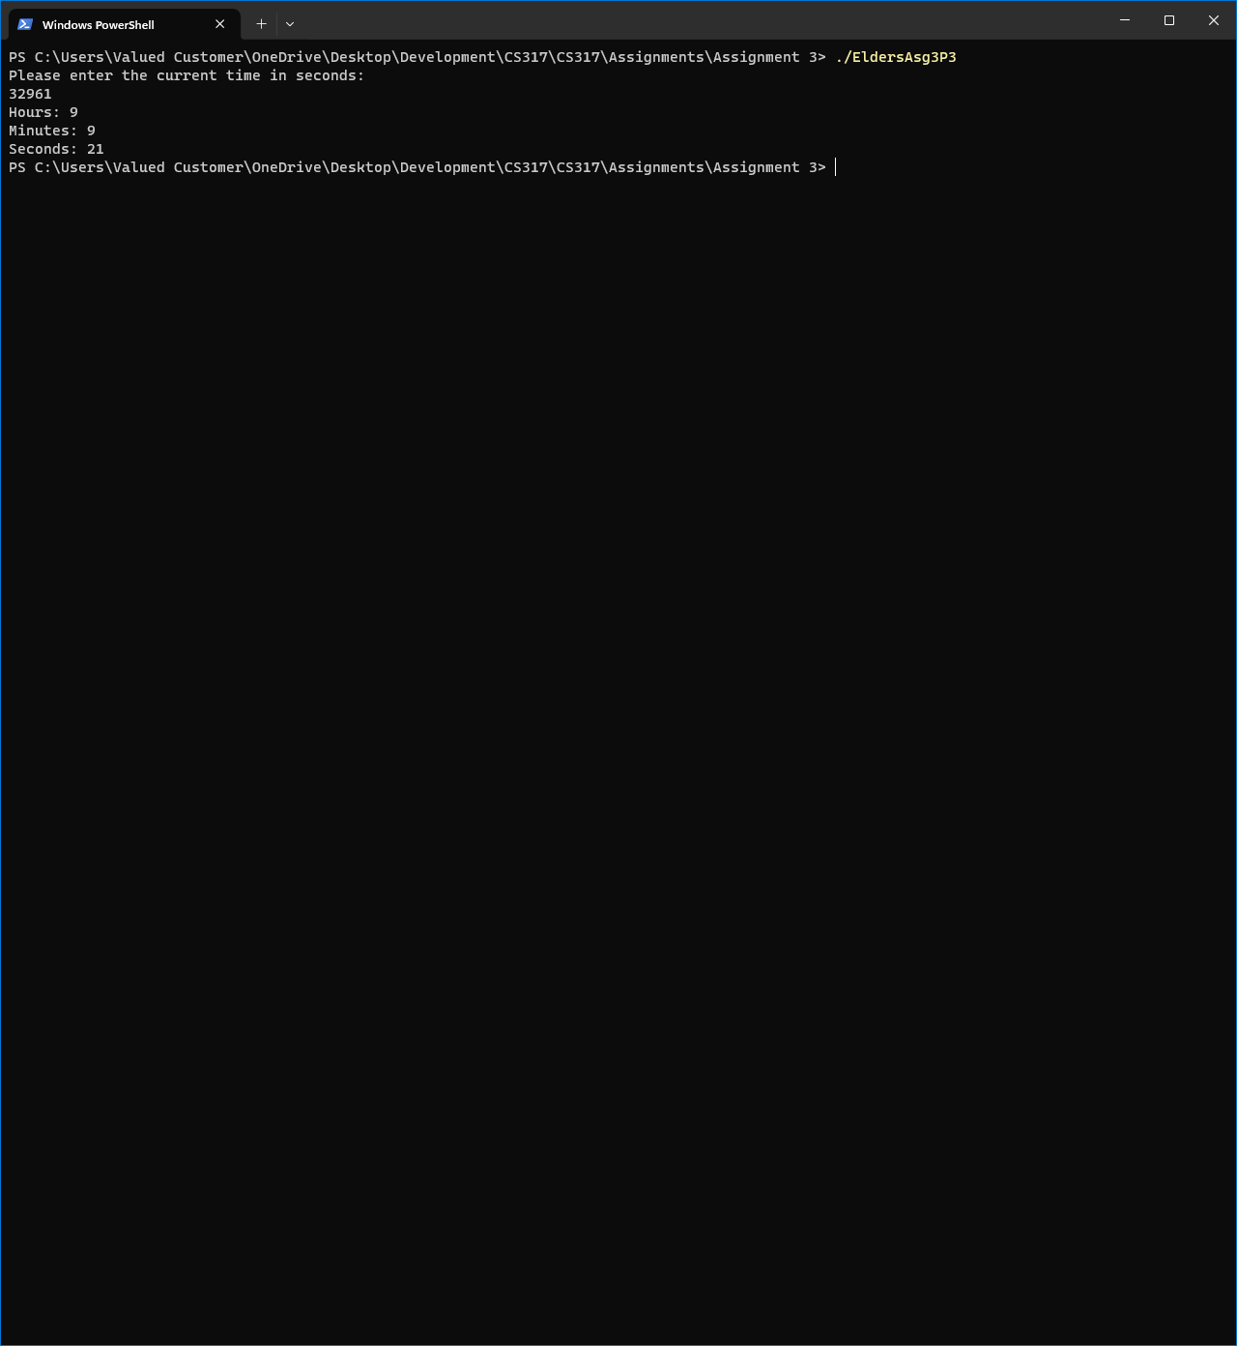
   3. 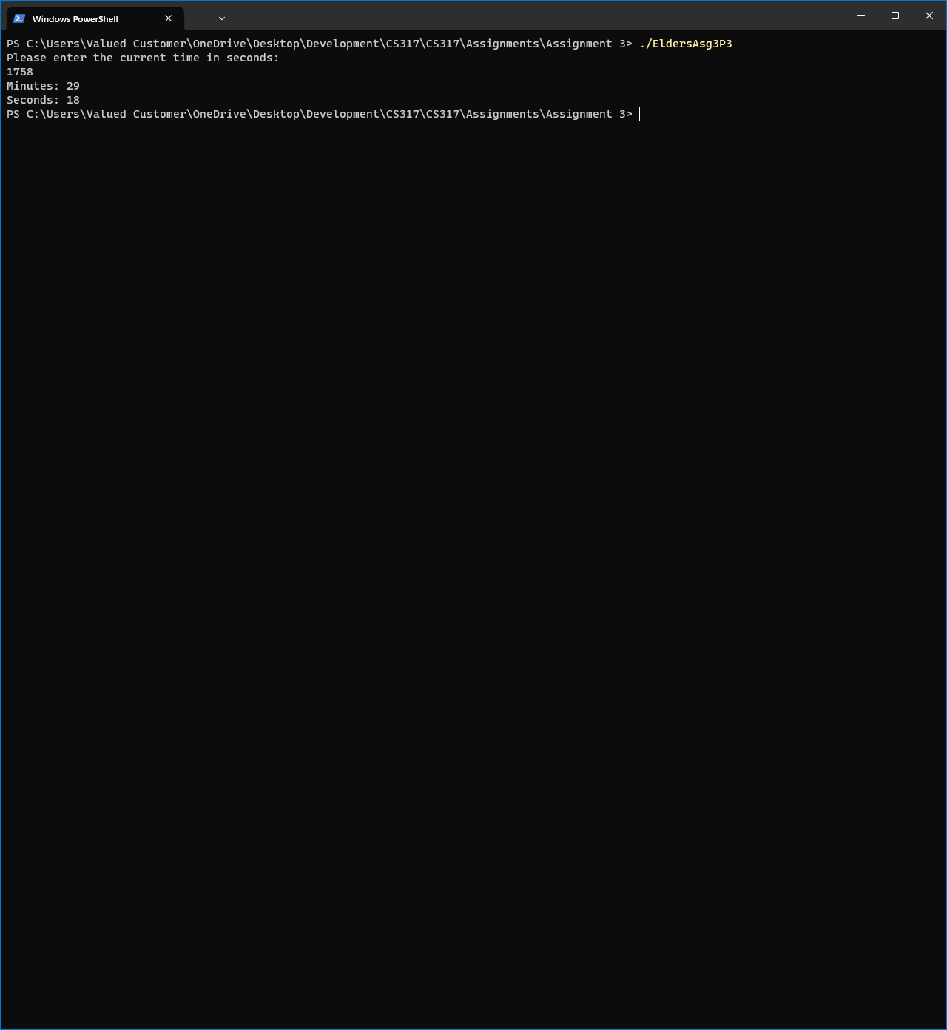
2. Menus, Decisions, and Validation
   1. 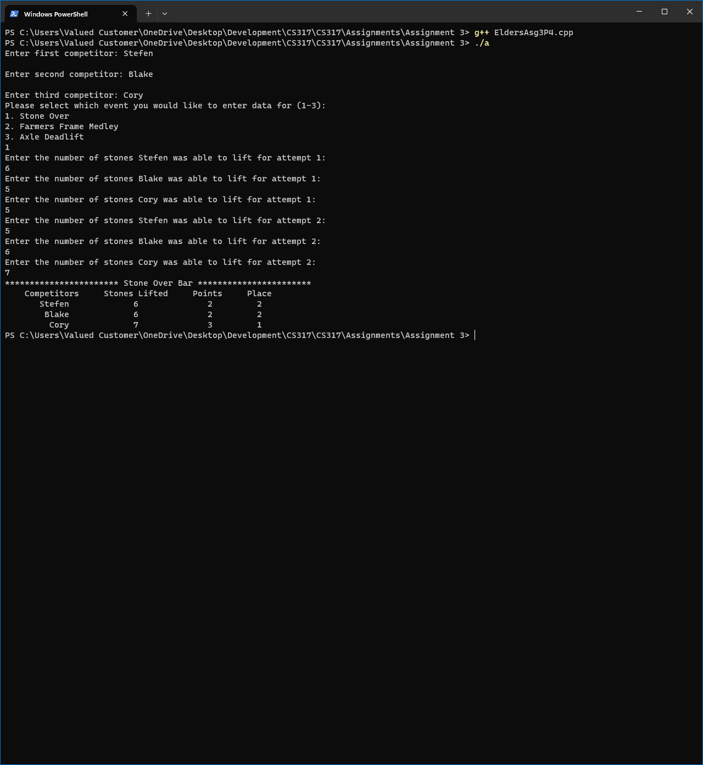
   2. 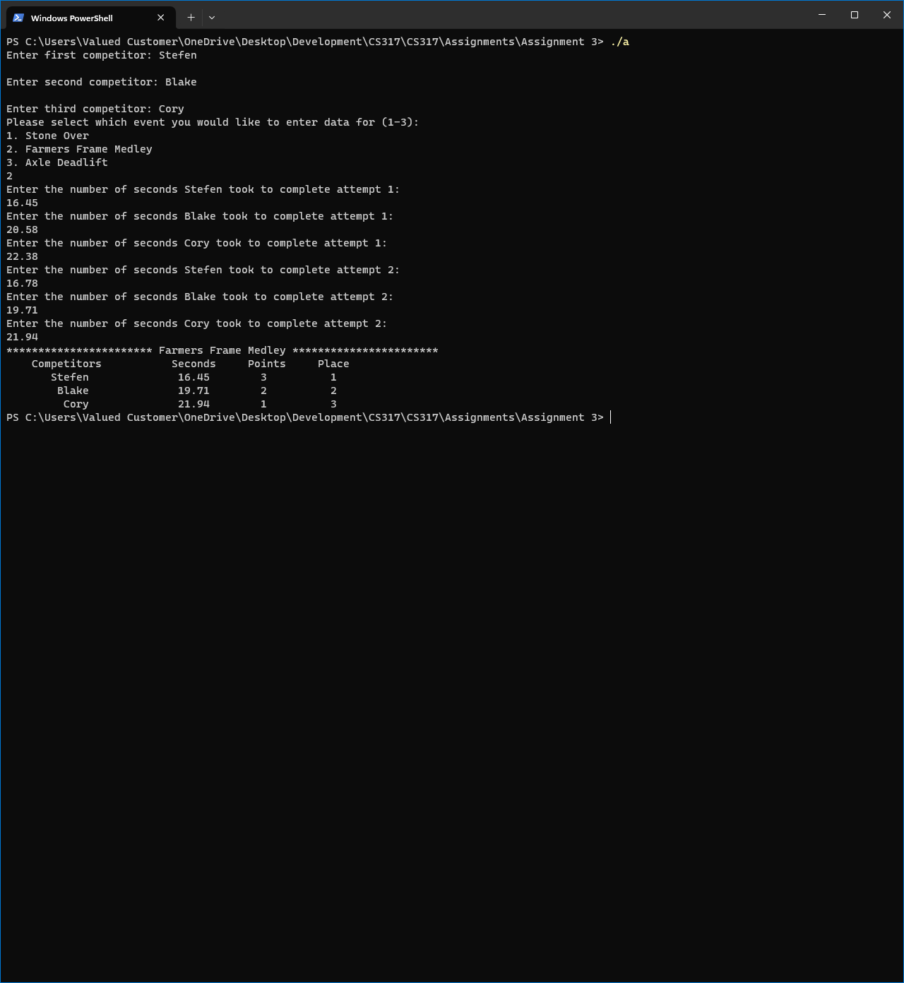
   3. 